Dear Guest
Your host is a member of the Zermatt Apartment Verein (ZAV). Since 2014, our guests have received a Quality Card. With the Quality Card, we offer you various activities at special rates.
For summer 2026, we have put together the following offers for you:

Offers are only valid with the respective voucher, which must be printed out and completed in full.

Rail trip to Gornergrat (01.05.2026 – 31.10.2026)
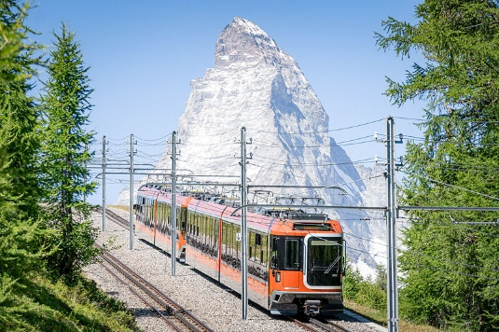
Return ticket to the Gornergrat

Adults CHF 112.- instead of CHF 132.-

Children with junior card free

Detailed information and ticket sales at the
Gornergrat railway station
Tel +41 (0)27 927 75 05 or www.gornergrat.ch

Matterhorn Museum (daily open until 31.10.2026)
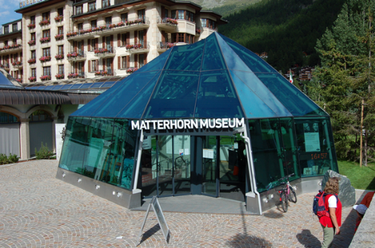
Entrance fee

Adults : CHF 7.- (instead of CHF 12.-)
Children 10-16 years : CHF 4.- (instead of CHF 7.-)
Children - 9 years : free
Opening hours : July, August, September 2-6 pm
: Mai, June, October 3-6 pm

Information: www.zermatt.swiss/museum

Shops offering 10% discount to ZAV guests:

ZAV guests receive a special 10% discount in the following shops.

Azzura Sport (-10%) on rentals (-15%) Salewa Mountain Shop
Matterhorn Sport (on rentals) Intersport Glacier
Bayard Sport Bahnhofplatz Dorsaz Sport (on rentals)
Davis Boutique Womy Express Laundry service
Icebreaker & Yosemite Bäckerei Fuchs (auf Bergführerbrot)
Timberland Lindt Shop
Marcopolo Zermatt Julen Sport (on rentals)

Free offers_______________________________________________________________________

- Zermatt library www.gemeindebibliothek-zermatt.ch

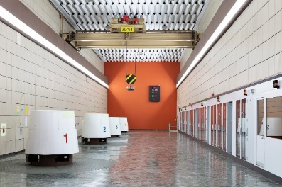
- Free guided tour of the Zmutt power station
Gain an insight into the Zmutt Power Plant.
Every Thursday at 10:00 a.m. from 11 June to 10 September 2026
Meeting point: Grande Dixence Zmutt (the tour is conducted in German)

Registration until Wednesday, 3:30 p.m. at the Zermatt Tourism office +41 (0) 27 966 8100 oder über https://ztnet.ch/grandedixence
Further informationen: Guided tour of the Zmutt Hydropower Plant

ZERMATTERS – Exploring with Our Outdoor Professionals

In cooperation with ZERMATTERS we offer the following group tours:


- Ascent of the Breithorn (4165 masl) –
The easiest 4000m peak in the alps…
Snow climb starting from Klein Matterhorn a certified mountain guide.
CHF 205.- per person (instead of CHF 225.-)

- Gorge Adventure - Via ferrata trough the gorner gorge
Crossing the Gorner Gorge with a certified mountain guide from Furi to Blatten.
CHF 135.- per person (instead of CHF 155.-)

- First snowXperience - Experience the fascination of skiing in the snowXperience Park on Testa Grigia, 3,458 meters above sea level. Come as you are – no previous experience required.
Price: CHF 119 per person (regular price CHF 139) – including equipment, entrance to the snowXperience Park, and 1.5 hours of group instruction with a ZERMATTERS ski instructor

- Bike Offers by ZERMATTERS
On all bike trips, you get a discount of CHF 20.- per course.
- Mountain bike rental at Bayard Sport shop, Bahnhofstrasse at 15% discount

Information: ZERMATTERS – Tel. +41 (0)27 966 24 66 www.zermatters.ch Bahnhofstrasse 58

Zermatt Bergbahnen AG – Mountaincarts (27.06. – 04.10.2026)
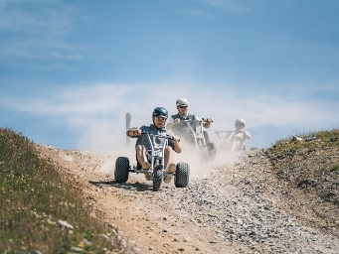
50 % reduction on rental of Mountaincarts
Mountain carts: Experience speed and adrenaline on three-wheeled go-karts from Rothorn to Blauherd.
Information: www.matterhornparadise.ch

Forest Fun Park (open daily from 01.05.2026 – 01.11.2026)
Rope Park "Zen Stecken" with easy and difficult passages – An adventure for the whole family!

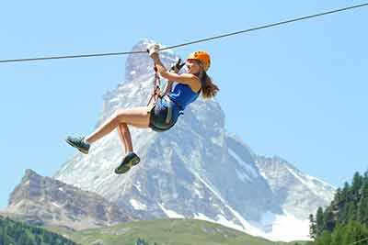
Adults : CHF 28.- (instead of CHF 38.-)
Youths (14-17) : CHF 23.- (instead of CHF 33.-)
Children (8-13 ) : CHF 18.- (instead of CHF 28.-)
Children (4-7) : CHF 12.- (instead of CHF 22.-)

No advance booking required.
Information:
+41 (0)27 968 10 10 or www.zermatt-fun.com

Swimming pools & Fitness centres (please ask about seasonal opening hours)
Those partner hotels offer reduced entrance fees !Advance booking is always required!

Swimming pools
Hotel Matterhorn Focus
CHF 15.- child CHF 5.- incl. bath towel (only indoor pool until 15.30h)
CHF 25.- child CHF 12.- incl. bath towel (Pool & SPA from 15.30h)
Hotel Alpenroyal
CHF 12.- child CHF 7.- (please register with the hotel first)
Hotel Silvana / Furi
CHF 30.- child CHF 20.- incl. bath towel (14.00h – 19.30h)
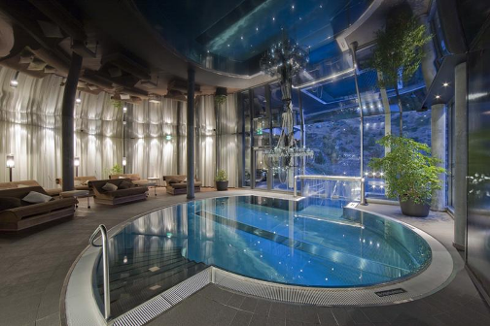
Fitness Centres
Aufenblatten Physio CHF 15.-
Massage 30 min. CHF 80.-
PFA Aufdenblatten GmbH - www.physiozermatt.ch

Massages (in house) 10% reduction from CHF 100.-
Beatrice Engel Hochscheid Tel: +41 (0)78 892 77 04

Tennishall Hotel Alex
CHF 50.-/h rackets & balls included
www.hotelalexzermatt.com/sport/tennis

Village tour Zermatt (23.06.2026 – 14.10.2026)

The village of Zermatt has been shaped by ancient traditions and modern tourism. The thrilling contrasts can be explored on a walk through the village.
Tuesday, guided tour in English, Wednesday, guided tour in German, Duration:16:30 h – 18:00 h

Price: CHF 5.- per person (regular price CHF 10.-)
Meeting point: Zermatt tourism – railway station
Contact: Zermatt Tourismus – info@zermatt.swiss - +41 (0)27 966 81 00

Village tour with two local brothers (every day 10 h / 13 h / 16 h)
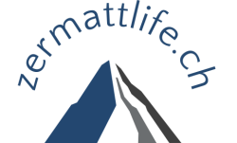
The two local brothers will guide you through their birthplace for two hours.
Get to know new places and corners of the village and hear interesting stories from then and now.

Price : CHF 25.- per person (regular price CHF 30.-/person)

Information: Tel: +41 (0)79 330 39 64 / +41 (0)79 341 83 25 - www.zermattlife.ch

Breakfast (Please show your quality card before ordering in the café/bistro)

Bakery Fuchs – Breakfast, coffee, and cake
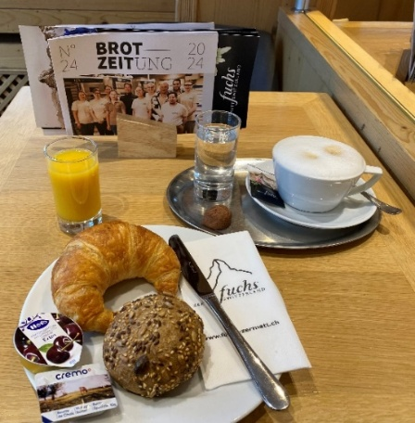
- Express breakfast with 1 roll, 1 butter croissant, 1 butter &
1 jam, 1dl orange juice,
One cup of coffee, tea or chocolate
Price: CHF 6.- (regular price CHF 12.-)

- Coffee and cake:
1 cup of coffee, tea or chocolate & 1 cake
Price: CHF 6.- (regular price CHF 12.-)

Daily open 07am – 6.30 pm, the voucher must be presented.
Bakery Fuchs, Getwingstrasse 24 & Bahnhofstrasse 28
www.fuchs-zermatt.ch

Breakfast ZERMAMA Bistro
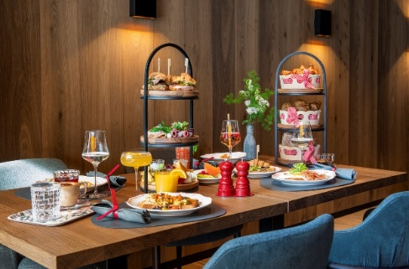
Large breakfast with egg dishes, various breads, croissants, jam, charcuterie, cheese, fruits, yoghurts, fruit juices, coffee/tea.

Price CHF 15.- (regular price CHF 30.-)

Daily open 07am – 11.30 am, the voucher must be presented.
Groups up to 4 people without advance booking
Hotel ZERMAMA, Matterstrasse 23 www.zermama.ch
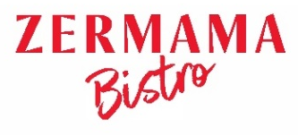

Tandem Paragliding FlyZermatt

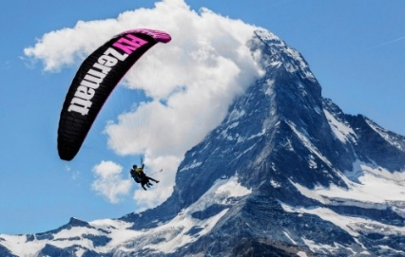
Tandem Paragliding with FlyZermatt

Flight from Rothorn or Gornergrat CHF 240.- (regular price CHF 280.-)
Klein Matterhorn CHF 420.- (regular price CHF 460.-)
Blauherd or Riffelberg CHF 190.- (regular price CHF 230.-)

Including free video/photo package

Reservation by phone: www.flyzermatt.com - Tel: +41(0)79 643 68 08

Matterhorn Paragliding

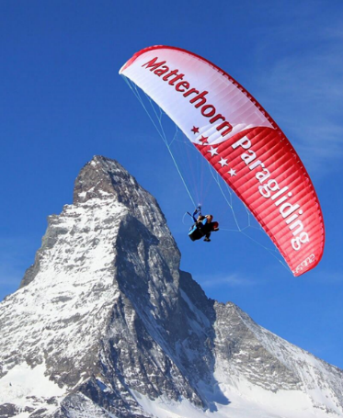
Tandem paragliding flight incl. Photo and video package

The Spectacular
(Rothorn / Gornergrat) CHF 240.- (regular price CHF 280.-)
The Ultimate
(Klein Matterhorn) CHF 420.- (regular price CHF 460.-)
The Adventurer
Blauherd or Riffelberg CHF 190.- (regular price CHF 230.-)

Information:
www.matterhornparagliding.com - Tel: +41 (0)79 489 59 16

Indoor Golf
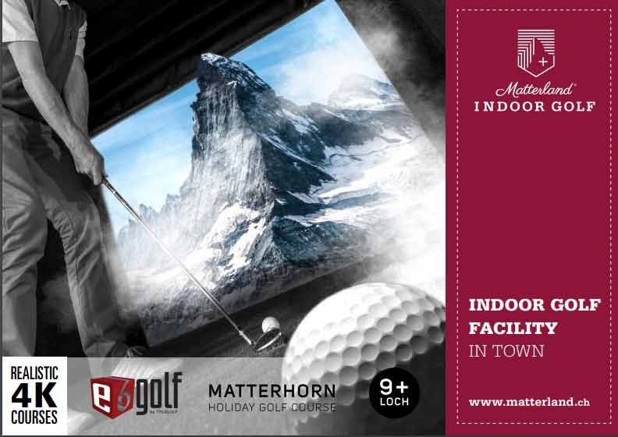
Indoor Golf in Zermatt
Price: CHF 70.- per hour (instead of CHF 90.-) / simulator
max. 4 people per hour per simulator

Information/reservation:
Tel: +41 (0)79 628 04 82 –
Mail: indoor-golf@matterland.ch

Thermal bath Brigerbad

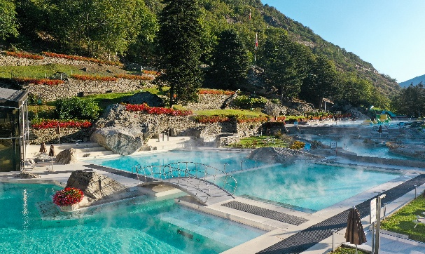
Entrance to the thermal bath Brigerbad
(Therme / SPA / Sport)

50 % discount on the entrance fee!

Information :
www.thermalbad-wallis.ch
Tel : +41 (0)27 948 48 48

Only with valid voucher !
Matterhörnli Workshop (01.05. – 30.11.2026)

Mould your own chocolate Matterhörnli in the confectionery of the Fuchs bakery
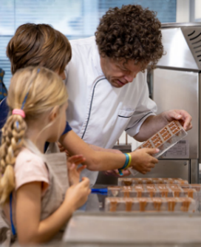
Duration: 1 – 1.5 h

CHF 500.- up to 8 pax. / additional per. CHF 40.- (max. 12 pers.)
Incl. 1 chocolate box Matterhörnli (15 Stk.) per person

With the quality card CHF 10.- reduction per person
Buchung unter https://fuchs-zermatt.ch/pages/workshops
Rabattcode: ZZ30FQSJNXWS

Virtual Reality Adventure and Escape games


Strange worlds full of puzzles and adventures await you in 22 different games
Duration : env. 1 hour

Price : 2 players CHF 35.-/pers. (NP CHF 50.-/pers.)
3 players CHF 30.-/pers. (NP CHF 45.-/pers.)
4 players CHF 26.-/pers. (NP CHF 40.-/pers.)

Information: www.getoutvr.ch – Tel: +41 (0)77 26 789 46

DINE AROUND ZERMATT (please check the seasonal opening hours)

You can book meals at reduced rates in various hotel restaurants. View the hotels and rates in ZAV Quality Card. Guests register directly with the chosen hotel as a “ZAV guest”.

Hotel Sivana / Furri 2 course menu including Pool / SPA CHF 50.-/person
www.hotelsilvana.ch 3 course menu including Pool / SPA CHF 75.-/person (min. 2 pers.)
Hotel Alex 1 glas of champagne offered…
www.hotelalexzermatt.com

Alm Restaurant / Furri, Schweigmatten 10% discount on food from the à la carte menu
https://alm-zermatt.swiss

Gornergorge ( 06.06. bis 15.10.2026)

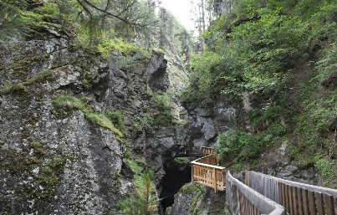
Publicly accessible gorge between Zermatt and Blatten.
The path through the Gorner Gorge was built in 1886/87.

Free of charge for ZAV guests – voucher must be presented!
instead of CHF 5.50 for adults and CHF 3 for children 6 to 15 years
Information : Tel : +41 (0)27 967 20 96 - www.blatten-zermatt.ch

NostalChic Class (24.06. – 19.09.2026)

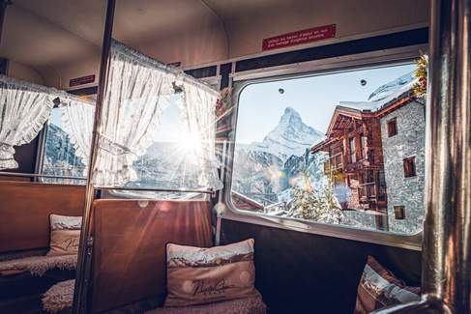
Your special day begins in Zermatt with a
warm welcome, a welcome drink and
exclusive apéro specialties at Edward's Café Bar in the
Hotel Monte Rosa. After a short, guided tour through
the old village, you will make your way to the valley station
of the Gornergrat Railway. Following an hour at the
Gornergrat, a first-class three-course menu awaits you at
Ristorante Al Bosco in the Riffelalp Resort 2222m. Enjoy
refined cuisine prepared with fresh local ingredients,
accompanied by carefully selected wines.

During the journey, let yourself be enchanted by the majestic alpine scenery and enjoy an exclusive photo stop for unforgettable pictures. Your multilingual concierge — not only an expert on the region, but also an engaging storyteller — will accompany you with fascinating anecdotes throughout the experience.

Price CHF 284.- instead of 320.-
Detailed information and direct booking at the Gornergrat Bahn valley station:
Tel. +41 (0)27 927 75 05 or www.gornergrat.ch

Waterski & Wakeboard Schalisee Täsch (from 04.06. – 27.09.2026)

Waterski & Wakeboard in Täsch - 20% discount for ZAV-guests

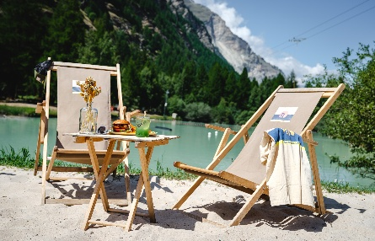
Schali Lago
Right in the middle of the mountains, yet so close to the beach! Just a few minutes from Zermatt lies the village of Täsch with its small Schalisee lake. Enjoy summer vibes with cool drinks, Mediterranean food, and guaranteed beach feeling.

Schali Lago by CERVO Mountain resort
Tel: +41 (0)27 968 12 12 - www.schalilago.ch

Flight Wine Tasting Swiss wines ((Closed on Tuesdays and Wednesdays)

In the heart of the village, at Bahnhofstrasse 50, the family-run wine shop Terravigna provides even more wine enjoyment in the holiday resort of Zermatt. The shop showcases more than 400 different wines, including exclusive champagnes, fine wines, and natural wines. We are happy to advise you personally in the shop! Whether shopping, enjoying a glass of wine, or attending a tasting, let yourself be inspired on site.

CHF 13.- statt CHF 21 per person
CHF 44.- statt CHF 54 per person with a traditional Valais platter
Buchen unter +41 (0) 27 967 11 13 www.terravigna.ch

We wish you an exciting summer in the destination Zermatt❤️ Matterhorn

